**Microprocessor and Computer Architecture Laboratory**

**UE19CS256**

**4th Semester, Academic Year 2020-21**

Date:

|  |  |  |
| --- | --- | --- |
| Name: Nihal T M | SRN: PES2UG21CS333 | Section: F |

Week#____5_______ Program Number: ____1_

**Write an ALP to read from a 2D array such that**

**B=a[i] [j]**

1. ARM Assembly Code (1).

Code:

@ ALP to implement B=a[i][j]

.data

matrix:.word 1,2,3,4,5,6,7,8,9

i:.word 1

j:.word 0

wrong_entry:.asciz "Invalid row and column"

B:.word 0

.text

ldr r1,=matrix

mov r2,#3

mov r3,#3

@ comparing the row and column to make sure it is a vlid access

ldr r4,=i

ldr r5,=j

ldr r6,[r4]

ldr r7,[r5]

cmp r6,#3

bmi valid_entry

b invalid_entry

invalid_entry:

ldr r0,=wrong_entry

swi 0x02

b end

valid_entry:

mov r10,#3 @ storing 3 for number of contents in the row

mul r8,r6,r10

mov r8,r8,LSL #2

add r8,r8,r7,LSL #2

ldr r9,[r1,r8]

ldr r11,=B

str r9,[r11]

end:

swi 0x11

.end

1. Output Screen Shot (One Example of your choice)

Here i=1 and j=0; We are trying to access the first element in the second row of the 3x3 matrix. The element is 4 and is present in register r9.

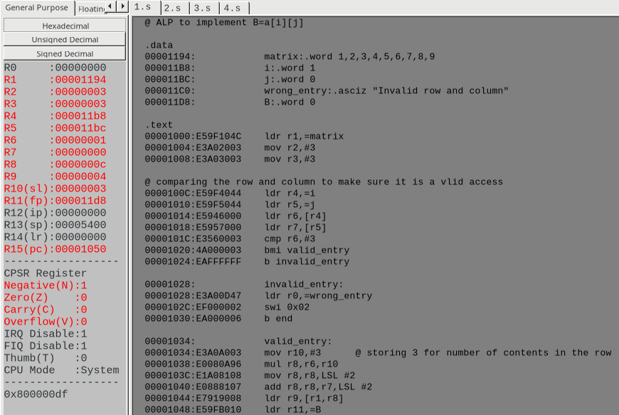

Week#____5_______ Program Number: ____2_

**Write an ALP to implement C[k]=A[i]+B[j]**

1. ARM Assembly Code (1).

Code:

@ ALP to implement C[k]=a[i]+b[j]

.data

a:.word 1,2,3,4,5,6,7,8,9

b:.word 11,12,13,14,15,16,17,18,19

C:.word 0,0,0,0,0,0,0,0,0

i:.word 4

j:.word 3

k:.word 7

error:.asciz "Invalid Indexes!"

.text

ldr r1,=i

ldr r2,=j

ldr r3,=k

ldr r4,[r1]

ldr r5,[r2]

ldr r6,[r3]

@ making sure we don't access illegal memory

cmp r4,#0

bmi fail

cmp r5,#0

bmi fail

cmp r6,#0

bmi fail

cmp r4,#8

bpl fail

cmp r5,#8

bpl fail

cmp r6,#8

bpl fail

ldr r7,=a

ldr r8,=b

ldr r9,=C

ldr r10,[r7,r4,LSL #2]

ldr r11,[r8,r5,LSL #2]

add r11,r10,r11

str r11,[r9,r6,LSL #2]

b end

fail:

ldr r0,=error

swi 0x02

end:

swi 0x11

1. Output Screen Shot (One Example of your choice)

The output it stored in register r11 and is then stored into memory as can be seen at the bottom right corner.

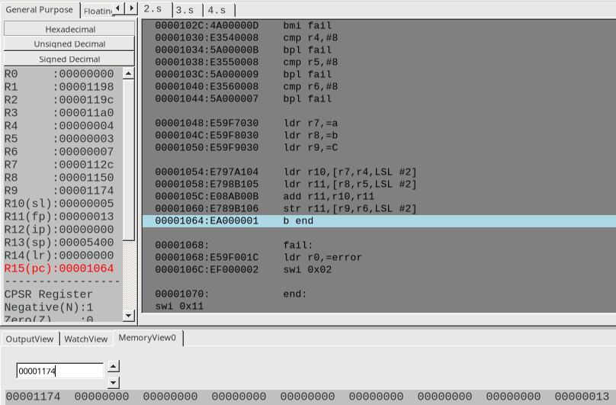

Week#____5_______ Program Number: ____3_

**Write an ALP to implement Sum[i] +=a[i][j]**

1. ARM Assembly Code (1).

Code:

@ ALP to calculate the sum of elements of each row in the matrix

.data

a:.word 1,2,3,4,5,6,7,8,9

Sum:.word 0,0,0

.text

ldr r1,=a

ldr r2,=Sum

mov r3,#3 @ stores number of elements in a row

mov r7,#3 @ number of rows traversed

mov r4,#0 @ stores current pointer

mov r5,#0 @ non-array sum

loop1:

loop2:

ldr r6,[r1],#4

add r5,r5,r6

subs r3,r3,#1

bne loop2

str r5,[r2],#4

mov r3,#3

subs r7,r7,#1

beq end

b loop1

end:

swi 0x11

.end

1. Output Screen Shot (One Example of your choice)

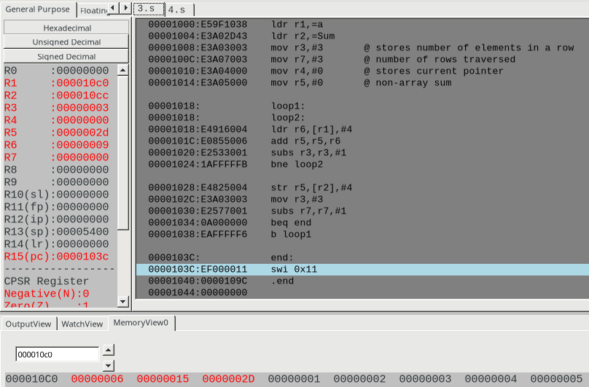

Week#____5_______ Program Number: ____4_

**Write an ALP to implement c[k] = a[i] * b[j]**

1. ARM Assembly Code (1).

Code:

@ ALP to implement c[k]=a[i]*b[j]

.data

a:.word 1,2,3,4,5,6,7,8,9

b:.word 9,8,7,6,5,4,3,2,1

c:.word 0,0,0,0,0,0,0,0,0

i:.word 4

j:.word 6

k:.word 2

.text

ldr r1,=a

ldr r2,=b

ldr r3,=c

ldr r4,=i

ldr r5,=j

ldr r6,=k

ldr r4,[r4]

ldr r5,[r5]

ldr r6,[r6]

ldr r7,[r1,r4,LSL #2]

ldr r8,[r2,r5,LSL #2]

mul r9,r7,r8

str r9,[r3,r6,LSL #2]

swi 0x11

.end

1. Output Screen Shot (One Example of your choice)

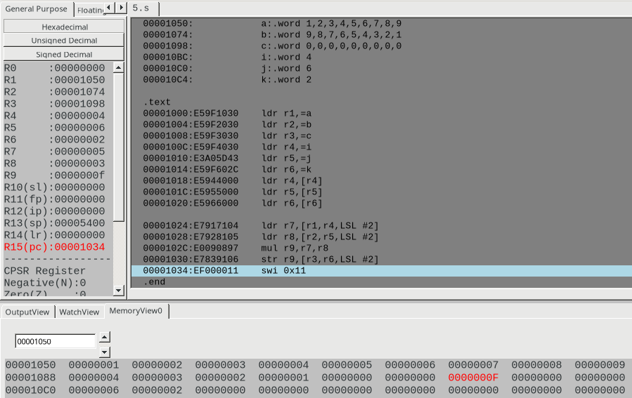

Week#____5_______ Program Number: ____5_

**Write an ALP to implement C[i][j]=a[i][j]+b[i][j]**

1. ARM Assembly Code (1).

Code:

@ ALP to implement C[i][j]=a[i][j]+b[i][j] (basically matrix addition)

.data

a:.word 1,2,3,4,5,6,7,8,9

b:.word 1,2,3,4,5,6,7,8,9

C:.word 0,0,0,0,0,0,0,0,0

.text

ldr r1,=a

ldr r2,=b

ldr r3,=C

mov r4,#3 @ stores the number of columns in the matrix

mov r5,#3 @ stores the number of rows in the matrix

loop1:

loop2:

ldr r6,[r1],#4

add r7,r7,r6

ldr r6,[r2],#4

add r7,r7,r6

str r7,[r3],#4

mov r7,#0

subs r4,r4,#1

bne loop2

mov r4,#3

subs r5,r5,#1

beq end

b loop1

end:

swi 0x11

.end

1. Output Screen Shot (One Example of your choice)

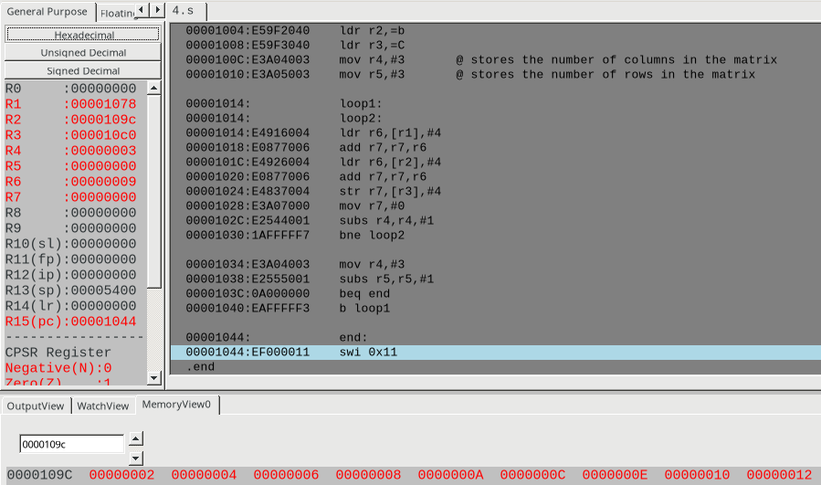

**Disclaimer:**

* The programs and output submitted is duly written, verified and executed by me.
* I have not copied from any of my peers nor from the external resource such as internet.
* If found plagiarized, I will abide with the disciplinary action of the University.

Signature:

Name: Nihal T M

SRN: PES2UG21CS333

Section: F

Date: 18/03/2023